**DEPARTMENT OF ARTIFICIAL INTELLIGENCE AND DATA SCIENCE**

**JOURNAL PUBLICATIONS**

1. Dr. Gayetri Devi S.V. published a research article titled *"Convolution Neural Network–AlexNet with Gazelle Optimization Algorithm-Based Software Defect Prediction"* in the journal, Knowledge and Information Systems (2025).  
   DOI: <https://doi.org/10.1007/s10115-025-02408-3>
2. Dr. Shaik Bajid Vali co-authored a research article titled “Seventeen-Level Inverter Model by Cascading Flying Capacitor and Floating Capacitor H-Bridges”, published in NeuroQuantology, Volume 22, Issue 2, in 2024. The article is accessible via DOI: 10.48047/nq.2024.22.2.NQ24018.

**IEEE CONFERENCE PUBLICATION**

1. Ms. S. Shafla Fathima published a research paper titled "User-Centric Drink Customization with Cloud-Powered Collaborative Filtering with Raspberry Pi Integration" in the 2024 11th International Conference on Reliability, Infocom Technologies and Optimization (Trends and Future Directions) – ICRITO, held on 14th and 15th March 2024. DOI: 10.1109/ICRITO61523.2024.10522377.
2. Ms. S. Shafla Fathima presented and published a research paper titled "Cloud Enabled Security for Luggage Protection through LSTM Networks and IoT in Contactless Travel" at the 2024 8th International Conference on I-SMAC (IoT in Social, Mobile, Analytics and Cloud), held from 3rd to 5th October 2024 at Amity University. Link: https://ieeexplore.ieee.org/document/10714792

**BOOK PUBLICATIONS**

1. Dr.Gayetri Devi S.V published a textbook titled "Object Oriented Analysis & Design", *Pencil Bitz Publication*, ISBN: 978-81-979572-6-0, October 2024.
2. Dr.Gayetri Devi S.V authored "Data Science and Machine Learning using Python", *First Edition, Scientific International Publishing House (SIPH)*, ISBN: 978-93-6132-423-9, August 2024.
3. Dr.Gayetri Devi S.V published a book titled "Artificial Intelligence", *Charulatha Publications*, ISBN: 978-93-6260-212-1, June 2024.

**BOOK CHAPTERS**

* Dr. Shaik Bajid Vali contributed to the topic “Internet of Things (IoT) Smart Wearable Sensors in Healthcare” in the year 2024, featured in the book AI and IoT Technology and Applications for Smart Healthcare Systems published by Routledge.

**NPTEL COURSES COMPLETED:**

1. Asst.Prof.Mr.P.Muniraja Chandra successfully completed a 12 weeks NPTEL online certification Course on “Accreditation and Outcome Based Learning” (Elite) from July 2023 to October 2023. (NPTEL-AICTE FDP).
2. Asst.Prof.Mr.P.Muniraja Chandra also completed a 4 weeks NPTEL online certification Course on “Teaching and Learning in Engineering” from January 2024 to February 2024. (NPTEL-AICTE FDP).
3. On 31st July 2024, Asst.Prof.Mr.P.Muniraja Chandra successfully completed the “Database Management System – Part 1” course through Infosys Springboard
4. Asst.Prof.Mr.P.Muniraja Chandra successfully completed a Course on Young Industry Enthusiast – Retail through Infosys Springboard on 31.07.2024

**FACULTY DEVELOPMENT PROGRAM (FDP)**

1. Asst.Prof.Ms. R. Kiruthiga, Asst.Prof.Ms. Shahana Fareen S., and Dr. Gayetri Devi S.V. successfully completed a Faculty Development Program on AI Tools from 17th to 21st February 2025 at Mahatma Gandhi Mission's College of Engineering and Technology.
2. Asst.Prof.Ms.Shafla Fathima.S participated in a Faculty Development Program on AI Tools from 15th to 27th July 2024 at Ramco Institute of Technology.
3. Dr. Gayetri Devi S.V. attended a Faculty Development Program titled "A GAN-based Hybrid Deep Learning Approach for IoT" from 16th to 21st December 2024, organized by the Department of Computer Science and Engineering, Vinayaka Mission's Kirupananda Variyar Engineering College.
4. Asst.Prof.Ms.Sindhuja.R participated in one week faculty development program on Machine learning algorithms and exploratory data analysis organized by Pantech eLearning on 08th July 2024 to 13th July 2024
5. Asst.Prof.Ms.Sindhuja.R participated in the five days faculty development Program on ‘Exploring the frontier of artificial Intelligence: Theory, application & ethics during 8th – 12th July,2024
6. Dr. Gayetri Devi S.V participated in One week Faculty Development Program on OBE & NEP 2020, during 10th to 14th June 2024, jointly organized by Internal Quality Assurance cell – IQAC, PBR VITS, Kavali and VIT-AP University, Amravati
7. Dr. Gayetri Devi S.V participated in One -Week Faculty Development Program on "Emerging Trends and Developments in Simulation and Fabrication of Semiconductor” between 2nd May – 8th May 2024, organized by School of Electronics Engineering (SENSE), VIT-AP University.

**WORKSHOP CONDUCTED:**

The **Department of Artificial Intelligence and Data Science**, Aalim Muhammed Salegh College of Engineering, Chennai, organized a workshop on **"Opportunities in Full Stack Software Development"** on **13th March 2025**.

* **Coordinator**: Asst. Prof. Mr. P.Muniraja Chandra
* **Speaker**: Mr. Arun Kumar R
* **Designation**: Software Development Engineer 3, Comcast India Engineering Centre LLP
* **Audience**: II & III Year Students (Artificial Intelligence and Data Science)
* **Venue**: AI&DS LAB
* **Date**: 14th March 2025

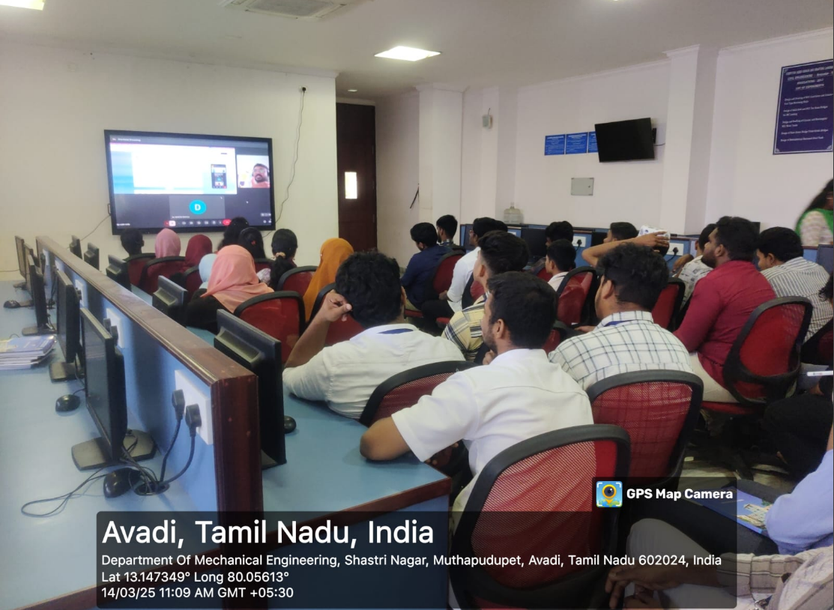

**INDUSTRIAL VISIT :**

1. An **industrial visit** was organized for **Third Year students** of the **Department of Artificial Intelligence and Data Science** to the **Reserve Bank of India, Chennai** on **28th August 2024**. This visit provided students with valuable insights into the functioning of India’s central banking institution and its role in the financial system.

**Coordinator**: Asst. Prof. Mr. P. Muniraja Chandra

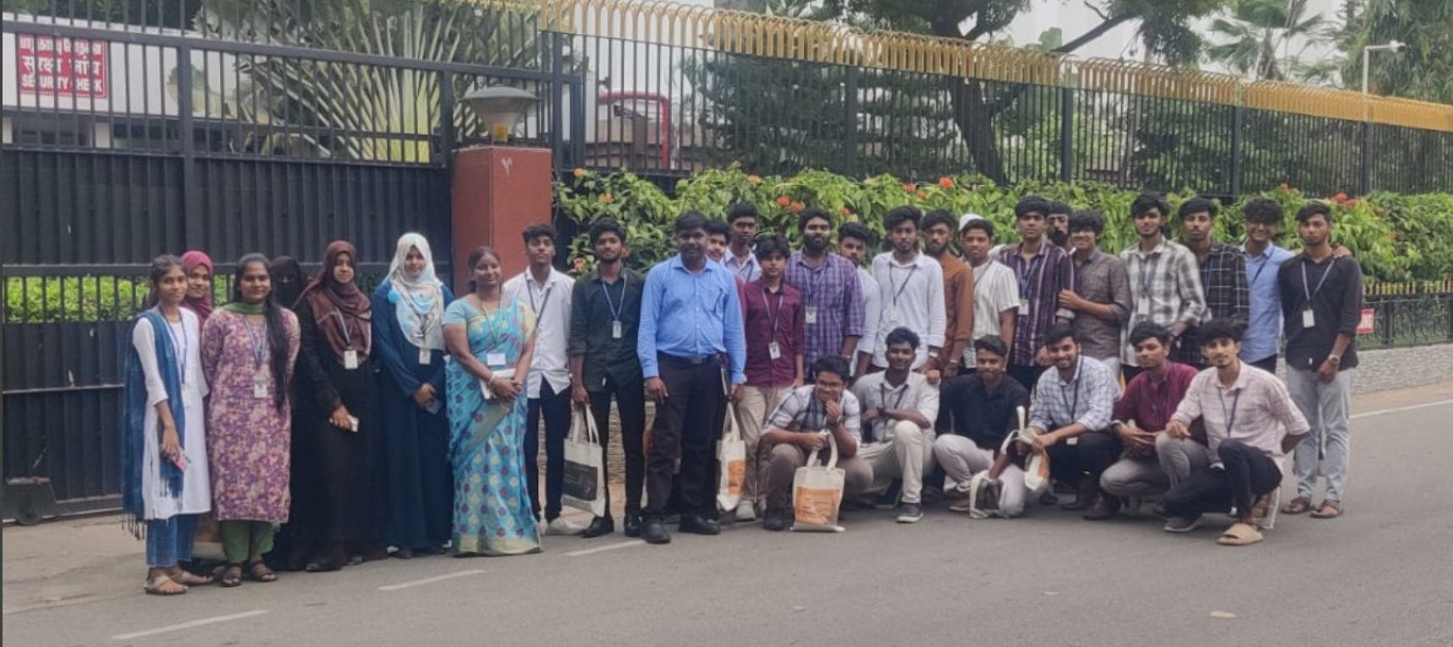

1. An **industrial visit** was organized for **Second Year students** of the **Department of Artificial Intelligence and Data Science** to **Kaashiv Infotech, Chennai** on **13th May 2025**. The visit aimed to provide students with practical exposure to industry practices and emerging technologies in the field of software development and data science.

**Coordinator**: Asst. Prof. Mr. P. Muniraja Chandra

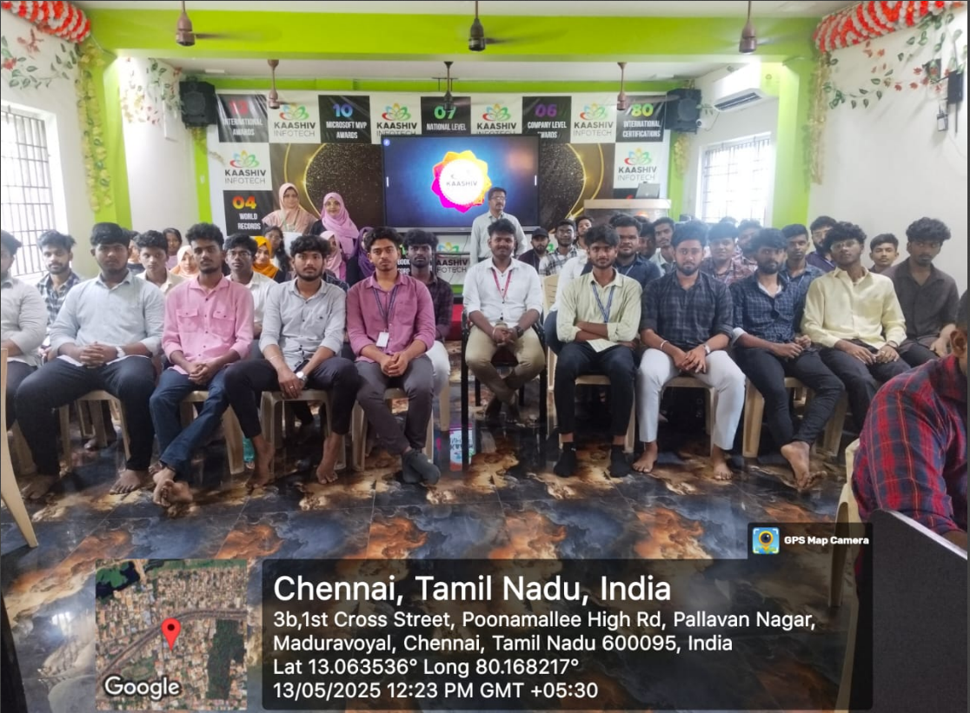

**WORKSHOPS ATTENDED**

1. Dr. Gayetri Devi S.V attended a session on *"Higher Education Opportunities with Top 5 Taiwanese Universities"* on 30th August 2024, organized by the International Affairs Offices of NTNU, NSYSU, CMU, CGU, and YZU.
2. Asst.Prof.Ms.Sindhuja.R participated in the Foreign Guest Lecture on Beyond Boundaries : Exploring the Frontiers of AI and its Transformative Potential organised by School of Computer Science and Engineering, VIT-AP University, Amaravati on 29th May 2024

**PATENTS PUBLISHED:**

1. Image To Text Conversion System Using Single- Board Computer For Physically Challenged Person

Faculty Members:

* Mr. MUNIRAJA CHANDRA .P
* Ms. SINDHUJA .R
* Dr. GAYETRI DEVI .S.V

1. A novel cylindrical protective enclosure for poultry with integrated food and water systems Dated 04/10/2024 -90889

* Mr. MUNIRAJA CHANDRA .P

**100% RESULTS IN ANNA UNIVERSITY END SEMESTER EXAMINATION**

1. Asst. Prof. Ms. Sindhuja R. secured 100% Pass Percentage in Computer Networks , Semester IV (April/May 2023-2024).
2. Dr. Gayetri Devi S.V achieved 100% pass percentage in:

* Design and Analysis of Algorithms, Semester III (Nov/Dec 2022-2023)
* Operating Systems, Semester IV (April/May 2023-2024)
* Soft Computing, Semester V (Nov/Dec 2023-2024)